To: Bill Pollack

From: Mike Sinnott

Date: February 11, 2020

Re: BetR Network - Chicago

Illinois Governor J.B. Pritzker signed the “Sports Wagering Act” (230 ILCS 45) into law on June 28, 2019. Currently, gambling on sports is not operational in the state. After the passage of the law, the state started the process of regulating sports gaming in the state. The Illinois Gaming Board (IGB) is the state regulatory body that will oversee sports betting.

Currently, the IGB is working to establish the regulatory infrastructure that will govern sports betting in the state. Currently, there are no adopted rules related to the Act, but emergency rules were adopted on January 28, 2020. This signals progress toward the launch of sports betting in the state. Although no definite timetable is in place for the launch of sports betting in the state, the emergency rules automatically expire after 150 days. Based on the expiration of the emergency rules, we could reasonably extrapolate that sports betting could be “live” in the state by the middle of the summer 2020. The goal is likely to be fully operational in time for football season by the fall of 2020.

A few important aspects of the law to keep in mind as we move forward and recommendations on how this can benefit your business:

Sports betting kiosks throughout the state
Illinois will have more than 2,500 sports betting kiosks where bets can be placed on sports. This is similar to the lottery scratch-off kiosks throughout the state. These kiosks will make sports betting available throughout the state and expand sports betting beyond the traditional retail sports books located in casinos.

This expansion of sports gaming throughout the state will increase interest in sports and sports betting. There is a direct correlation between legalization of sports betting and an increase in the demand for relevant, real-time information about the sports betting markets. VSiN and “The BetR Network” are the CNBC of sports betting, delivering information from entertaining, passionate, and informed hosts.

Sports betting at venues with capacity of 17,000 or more
The law allows for sports betting at sports venues with a capacity of 17,000 or more. The sports venues eligible to include on-site sports betting are: Soldier Field; Wrigley Field; Guaranteed Rate Field; Seat Geek Stadium; Chicagoland Speedway; and Worldwide Technology Speedway.

This creates an opportunity for a station to create a BetCast for bettors attending the games at these venues. The BetCast would reach those attending the game and betting in-play during the game. The BetCast doesn’t necessarily need to be from a radio station within ear-shot of the

“Brick & Mortar” retail sports books located inside casinos
Brick-and-mortar casinos will have traditional sports books. The laws governing them have yet to be written by state regulators. Currently, there are ten casinos in the state and five in Chicagoland (highlighted), including:

 | CASINO | LOCATION
 | CASINO QUEEN | EAST ST. LOUIS (ST. CLAIR)
 | HARRIAH’S JOLIET | Joliet (Will County)
 | HARRAH’S METROPOLIS | Metropolis (Massac County)
 | Hollywood Casino Aurora | Aurora (Kane County)
 | Grand Victoria Casino Elgin* | Elgin (Kane County)
 | Hollywood Casino Joliet | Joliet (Will County)
 | Argosy’s Alton Belle Casino | Alton (Madison County)
 | Rivers Casino* | Des Plains (Cook County)
 | Par-A-Dice Casino | East Peoria (Tazewell County)
 | Jumer’s Casino & Hotel | Rock Island (Rock Island County)

In addition, the new law authorizes six new casinos in the state. It is likely that those casinos will include sports books as part of the gaming menu. The expansion of gaming options in the state will increase the number of players throughout Illinois, creating an audience for this content.

Under the provisions of the law, Chicago will have its first casino, a privately-owned venture. The Chicago Casino will not open until 2022 at the earliest. In addition, future casino locations include: Danville, Rockford, Waukegan, and Williamson counties.

*As of February 20, 2020, the IGB lists two casinos that have applied for licenses to operate sports books in the Chicagoland area, including:

-Grand Victoria Casino (Elgin Riverboat Resort)
250 S. Grove Avenue
Elgin, IL 60120

-Rivers Casino (Midwest Gaming & Entertainment, LLC)
3000 S. River Road
Des Plaines, IL 60018

Although these are the only two Chicagoland casinos to apply for a license to engage in sports wagering, it is anticipated that each casino in the market will eventually add retail “brick-and-mortar” sports books at their respective casinos while also offering digital sports betting.

Digital betting is a critical component of the new law, effectively expanding sports betting statewide. Anyone inside the border of Illinois will be able to bet on sports, regardless of whether or not they’re physically inside a retail betting location. This expands the potential advertising pool to anyone operating a digital sports-betting platform in the state. With a population of 9.5-million, Chicagoland is a must reach audience for anyone marketing their sports betting products and/or platforms.
Draft Kings and Fan Duel have been placed in a punitive “penalty box” for 18 months and are unable to operate in Illinois under those brand names. This is a punitive measure for operating as a de facto gambling site, illegally, for several years.

Draft Kings and Fan Duel could technically operate an online betting site for a casino partner, but not under the hose brand names. In addition, Rush Street Interactive is moving into the market with online sports betting similar to what they’re currently doing for Philadelphia’s Sugar House Casino. Rush Street Interactive could be a partner for radio advertising on your station.

Vegas Stats & information Network (VSiN): Delivering content to multiple platforms
As the radio platform of the Vegas Stats & information Network (VSiN), the industry leader in sports betting news and information, The BetR Network delivers unrivaled sports betting coverage to radio stations nationwide.

Our programming originates from the floor of the sportsbook at the South Point Hotel & Casino on the strip in Las Vegas, Nevada. Each month, VSiN programming makes more than 41-million impressions on multiple platforms, including:

-VSiN.com;
-The BetR Network;
-SiriusXM;
-TuneIn;
-Madison Square Garden (MSG) Networks;
-New England Sports Network (NESN);
-fuboTV; and,
-Sling TV.

Even in the highly-competitive sports media landscape, “The BetR Network” stands alone with its unique content offering for radio stations.

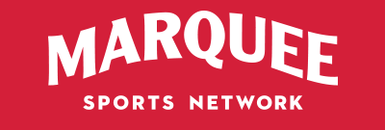

MARQUEE SPORTS NETWORK to air VSiN’s “Follow The Money”
Starting on February 22, Marquee Sports Network will start airing VSiN’s morning show, “Follow the Money.” The new regional sports network will be the new television home of the Chicago Cubs. This presents an opportunity to promote your stations on this regional cable network.

An alternative to Chicago’s sports-talk giants
As a BetR Network affiliate, your stations will not compete with Chicago’s sports-talk giants, WMVP-AM and WSCR-AM. Instead, your stations will a unique voice to the market’s sports-talk landscape. Instead, with programming from The BetR Network, your stations will be positioned as an alternative to the two heritage brands, delivering a unique gambling perspective on sports.

Although the two heritage sports-talk brands dominate the market with compelling sports talk, there is room for a sports format that actually talks about sports. BetR Network shows are focused on delivering information that bettors need to win at the sports book, featuring expert analysis from the biggest names in sports and sports betting. Our format talks directly to an audience that doesn’t want the same-old sports-talk radio, but real-time, actionable information about the sports of the day. This is an engaged audience with more than a rooting interest in the games of the day.

An audience that puts its money where its mouth is: $5.8-BILLION wagered on sports in NJ
Interest in the format is apparent when you consider the incredible amount of money wagered on sports in New Jersey. Since June 2018, when New Jersey handled its first sports wager, there have been more than $5.8-billion wagered on sports betting in the state. In May, New Jersey’s legal sports books handled $318.9-million in wagers, besting Nevada’s “handle” for the first time.

The Garden State’s average sports betting handle has averaged $306,858,737.31 each month. A trend is emerging in New Jersey in which the online handle is far outpacing the bets placed in retail locations.

Keep in mind that more people live in Chicagoland (9.5-million) than live in the entire state of New Jersey (8.9-million).

NEW JERSEY: SPORTS BETTING HANDLE

MONTH | RETAIL HANDLE | ONLINE HANDLE | TOTAL
Dec-19 | $ 68,933,821.00 | $ 488,931,379.00 | $ 557,865,200.00
Nov-19 | $ 75,890,898.00 | $ 486,784,645.00 | $ 562,675,543.00
Oct-19 | $ 70,959,985.00 | $ 416,964,519.00 | $ 487,924,504.00
Sep-19 | $ 71,317,160.00 | $ 374,246,343.00 | $ 445,594,503.00
Aug-19 | $ 44,357,272.00 | $ 249,237,590.00 | $ 293,594,862.00
Jul-19 | $ 38,332,533.00 | $ 213,038,739.00 | $ 251,371,272.00
Jun-19 | $ 46,520,409.00 | $ 226,702,566.00 | $ 273,222,975.00
May-19 | $ 55,388,358.00 | $ 263,552,319.00 | $ 318,940,677.00
Apr-19 | $ 59,743,318.00 | $ 253,976,244.00 | $ 313,719,562.00
Mar-19 | $ 74,169,188.00 | $ 298,282,154.00 | $ 372,451,342.00
Feb-19 | $ 61,496,490.00 | $ 258,871,597.00 | $ 320,368,087.00
Jan-19 | $ 80,305,676.00 | $ 304,973,986.00 | $ 385,279,662.00
Dec-18 | $ 78,130,359.00 | $ 241,043,289.00 | $ 319,173,648.00
Nov-18 | $ 92,132,952.00 | $ 238,615,611.00 | $ 330,748,563.00
Oct-18 | $ 86,341,617.00 | $ 174,369,684.00 | $ 260,711,301.00
Sep-18 | $ 79,062,731.00 | $ 104,885,673.00 | $ 183,948,404.00
Aug-18 | $ 73,919,891.00 | $ 21,714,157.00 | $ 95,634,048.00
Jul-18 | $ 40,682,237.00 | N/A | $ 40,682,237.00
Jun-18 | $ 16,409,619.00 | N/A | $ 16,409,619.00
TOTAL |  |  | $ 5,830,316,009.00

Audience Profile
This audience of engaged listeners will deliver results for your station and your advertising partners. According to the American Gaming Association, sports bettors are:

-male (69% of sports bettors are men);
-young (44% under the age of 35);
-educated (53% bachelor’s degree or better); and,
-professional (29% with a household income of more than $100,000).

The sports betting audience is younger than the traditional sports-talk audience, more educated, and with more disposable income to spend outside of sports betting. A number of traditional categories appeal to the sports bettor, including:

-entertainment (sporting events, movies);
-travel & leisure;
-financial services;
-insurance;
-electronics; and,
-luxury automobiles.

Advertising partners will extend well beyond sports books and sports betting web sites. This is a desirable audience that goes well beyond those advertisers. VSiN has delivered results for many national advertisers, including:

-Indeed;
-Lumber Liquidators;
-Blink Home Security;
-Blue Emu;
-Med Men; and,
-O’Reilly Auto Parts, among others.

Non-Traditional Revenue Opportunities
Our recommendation is to expand your sales offerings beyond the traditional commercial campaigns for these advertisers. While these campaigns are effective, there are additional ways to generate revenue for the station, including:

-brokered programming blocks paid for and produced by the sportsbooks;
-live shows from the sportsbooks paid for and produced by the sportsbooks; and,
-hourly sponsorships to the exclusion of other sports books.

Exclusive, Exclusionary Programming Hours
The brokered programming will generate revenue at an hourly rate with minimal cost to the station. Outside of the brokered programming, the station could sell exclusionary hours in which BetR Network programming is sponsored by the sports book to the exclusion of their competitors. Local liners would proclaim that this hour is brought to you by the advertiser and only that sports book will be allowed to advertise during that hour. This would be a premium hour of advertising for the sports book.

Chicagoland’s Sports-Betting Summit
The entire Midwest is a nascent sports betting market. Although there are some seasoned sports bettors who have previously placed bets - whether legally or on the black market - a higher percentage of potential sports book customers are new to the game. We will work with your stations to host a sports-betting seminar to educate potential sports bettors about how to place bets, mistakes to avoid, the different betting markets available, and the nuances of sports betting.

The seminar will be hosted at a local sportsbook or casino ball room. The two-day seminar will include sports betting experts, odds makers, professional bettors, and sports personalities, delivering the info that the public needs to beat the sportsbook. A portion of the show will be broadcast live on your stations, The BetR Network, and VSiN.

In addition to sponsorship opportunities for advertisers, including the title sponsorship of the event, the right to host the seminar, and access to the list of attendees, we will charge a fee to attend event. That cost could be determined at a later date, but a fee of $250 per person for this exclusive opportunity to learn the ins-and-outs of sports betting from prominent pro bettors, handicappers, and bookmakers. It would be a reasonable investment for serious sports bettors and those interested in learning more about how to bet and win at the sports book.

Station branding to set it apart from the competition
Now it’s time for something completely different . . . The BetR Network offers an alternative to the current sports-radio landscape. The BetR Network is sports talk that actually talks about sports, delivering relevant, actionable information that bettors can use to win at the sports book. We will work with you to develop your station branding.

Here are a few branding suggestions:

BetR 1410 (BetR = Bettor)
The BetR Network is new, fresh, and decidedly different than the other network sports-radio brands available in radio. Besides, The BetR speaks directly to our audience of bettors and those looking for a different perspective on the games of the day. We focus on delivering relevant, real-time information that the bettor can use to win. The BetR Network focuses on the news, information that the bettor needs to win at the sportsbook.
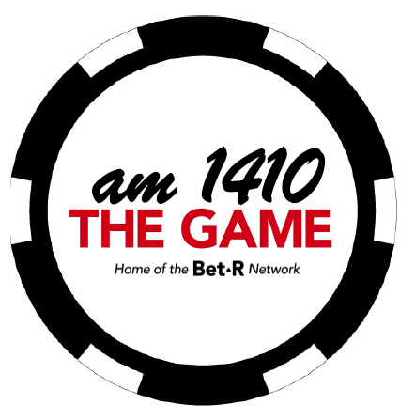
1410 The Game
This station will focus on what matters most to sports fans – The Game. There’s a double meaning here in that bettors are concerned with not only the game on the field, but also the game that they’re playing, whether they’re betting point spreads; money lines; totals; season win total; and/or prop bets.

The station will feature programming that focuses on the games on the field and the games our listeners play at the sports books. No more sophomoric guy talk; no more hot takes; no more politics invading sports; no more hosts begging for callers and then berating them. The Game will feature sports talk that actually talks about sports, focusing on the games, the players, the coaches, and the fans that live for sports. At the end of the day, for our listeners, “THE GAME” is what matters most.

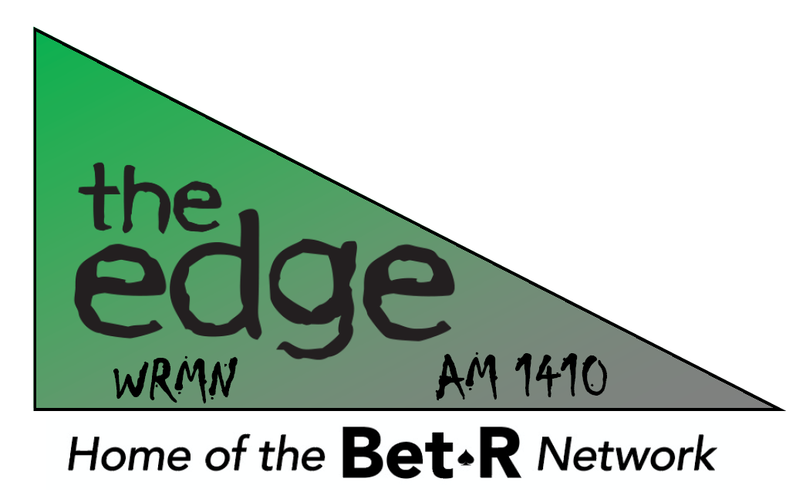
1410 The Edge
Featuring an unprecedented lineup of sports betting experts from across the country, the station will give listeners “The Edge” they need to beat the books.

In a crowded sports-radio marketplace, The BetR Network offers an alternative to the other networks. We will work with your station to create branding that will set your station apart from the others in the market.

Our affiliate station in Reno, Nevada is using a variation of this branding as “The Player’s Edge.” Here’s is the station logo:

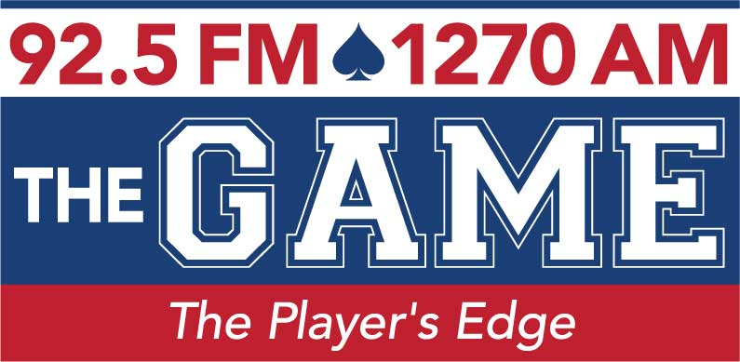

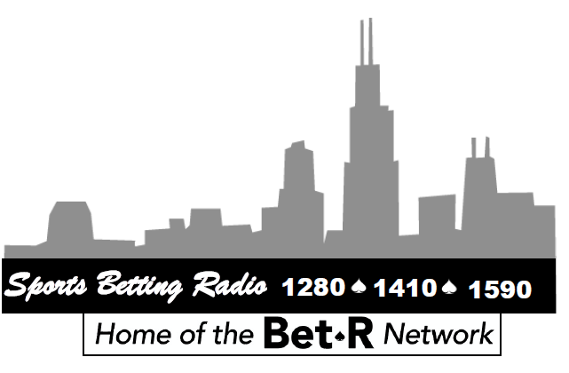
Sports Betting Radio 1280-1410-1590 - Chicagoland’s home of the BetR Network
We have found that branding as “Sports Betting Radio” helps to differentiate the station in the marketplace, giving a clear message to listeners about exactly what listeners will hear on the station.

Our full-time affiliate in Atlantic City, New Jersey chose the branding “Sports Betting Radio.” Here’s that station’s logo:
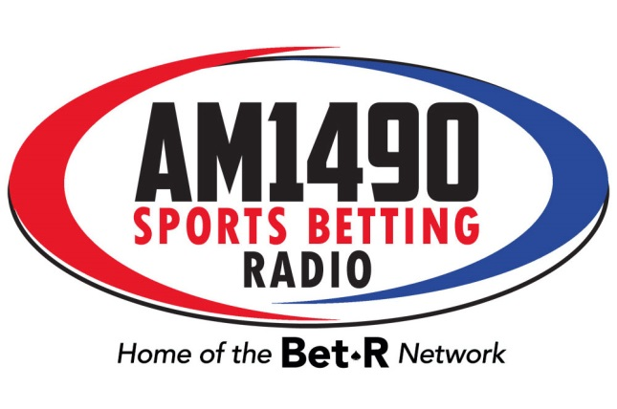
VSiN-produced, market-specific programming
We have the capability of producing long-form, market-specific sports betting programming that focuses on teams that matter most to your listeners, including the Bears, Bulls, Cubs, White Sox, and Blackhawks. We could even include your station branding, commercials, and promos in the show. Just send us whatever you’d like us to include and we’ll take care of the rest. Each week, we’ll deliver a fully-produced show for you to air on your station.

Our goal would be to make the show sound as if it was produced in-house at your station. For this show, the inventory requirements would be the same as with our “traditional” network programming or 10.5-minutes of local commercials and 5.5-minutes of network commercials.

Unlike our other programs, we will pre-produce the show and make it available for download via our Dropbox or via FTP from an address on our server. We could produce this show to air on weekday or weekend mornings, leading into your other local and/or network programming.

We’re wide open to helping you fill any programming needs that you may have. Just let us know what you need, and we’ll put something together for you. This will give you a “local” sports-betting show without an investment in a staff to produce the show.

Brent Musburger’s VSiN Action Updates
This is our short-form programming feature that focuses on the betting information on the teams that matter most to your listeners. This is a self-contained feature and we only require the “live read” included in the report from Brent Musburger for our national advertisers. If you want to sell a local sponsor, just send us the copy and we’ll have Brent record that copy to include in the updates. In that instance, we would require ROS inventory in exchange for that local sponsor insertion.

Promotion of your BetR Network affiliation
We will leverage our many assets to promote BetR Network programming on your station, including:

-promotion of station on the “Follow the Money” broadcast on Marquee Sports Network;
-click-through banner ads on VSiN.com;
-advertisement in our daily newsletter; and,
-advertisement in our weekly digital sports-betting publication, Point Spread Weekly.

Sales & Marketing support for your station
As a BetR Network affiliate, we will provide support to your sales efforts to attract local and national advertising. We will leverage our contact in the gaming industry to help secure advertising partnerships for you with your local casinos and sports books.

Summary
Although we would welcome the opportunity to convert your stations (WRMN-WBIG-WCGO) to full-time BetR Network affiliates, we understand that is not a likely proposition. We do propose the following:

-airing of BetR Network shows during your available hours;
-sports-betting centric branding during the airing of BetR programming; and,
-airing of our Brent Musburger Action Updates during your entire broadcast day.

This is a tremendous revenue opportunity for your station to secure a significant revenue stream from not only sportsbook properties, but also advertisers interested in this educated, professional audience with plenty of disposable income.

Let’s talk again soon.

Mike

