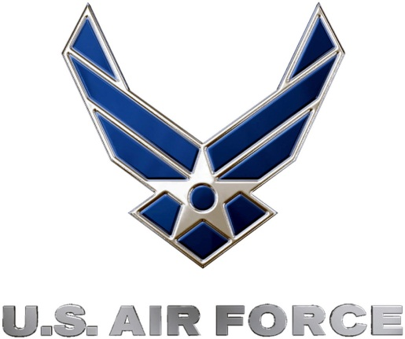
349th Recruiting Squadron launches U.S. Air Force Precision Air Strike of the Week campaign for Kansas
Air Force to honor the best passing combinations in Kansas high school football
FOR IMMEDIATE RELEASE CONTACT: Mike Sinnott
August 22, 2011 (517) 927-4570

OKLAHOMA CITY, OK - The U.S. Air Force’s 349th Recruiting Squadron is honored to announce the launch of the U.S. Air Force Precision Air Strike campaign that will honor the best high school football passing combinations In Kansas. Each week, the Air Force will honor the best quarterbacks and wide receiver combinations in the state. The weekly winners will be finalists for the U.S. Air Force Precision Air Strike of the Year.

“The Sports Flash” (TSF) Radio Network will accept nominations each week from high school football coaches, athletic directors, the media, and high school football fans. High school football fans will vote online for the weekly winner and each weekly winner will be a finalist for the U.S. Air Force Precision Air Strike of the Year. Each U.S. Air Force Precision Air Strike of the Week will receive a tee-shirt and certificate.

Throughout the campaign, fans can visit www.TheSportsFlash.com to state updated on the campaign, vote for the weekly winner, and much more.

For the U.S. Air Force, people are its most valuable asset. Without them, even the most advanced systems are rendered useless. The U.S. Air Force recruits quality airmen from a cross-section of America to meet the Air Force’s ever-changing needs. The Air Force has more than 140 enlisted career opportunities available for qualified men and women. For more information about the enlisted, officer, and healthcare professional job opportunities in the U.S. Air Force, contact your local Air Force recruiter. Recruiter contact information is available by calling 1-800-423-USAF (8723) or visit the Recruiter Locator link on the official Air Force recruiting web site at www.airforce.com.

“The Sports Flash” (TSF) Radio Network delivers customized, local sports reports for 190 network affiliates in 13 states. TSF Radio Network coordinates the U.S. Air Force Air Strike of the Week campaign for the 349th Recruiting Squadron. For more information, please contact TSF Radio Network’s Mike Sinnott at (517) 927-4570.

###

